T-Clip
Fittings + accessories for
aluminium profiles

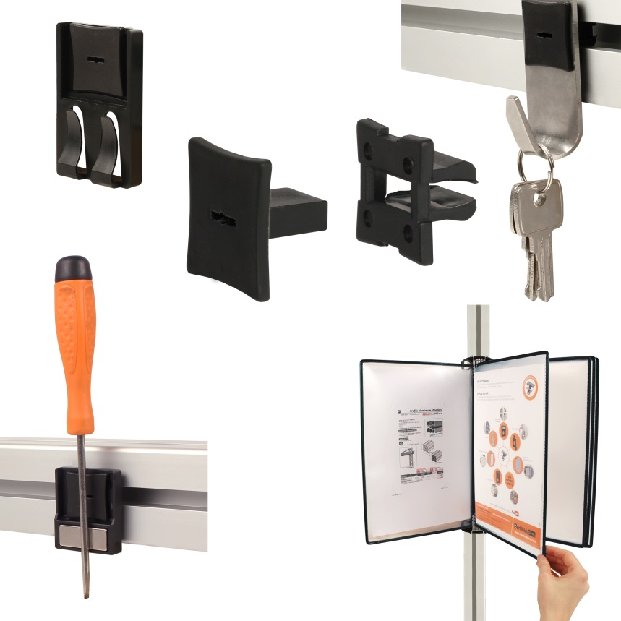

ENGRENAGES HPC has extended its range of accessories for aluminium profiles with an innovative fastening system that can be used with almost all profiles. Thanks to its patented shape, the T-Clip fits into the 8 or 10mm grooves of most profiles available on the market. These accessories can hold any object weighing up to 5kg and consist of an insert and a key, no additional tools are required for mounting. They can be used with any element that has a suitable 15mm diameter hole. Amongst the many accessories offered by HPC are:
- A document holder with 2 mounting tabs that can attach from 1 to 5 sheets to an aluminium profile
- A cable holder that capable of supporting 2 separate sets of cables or wires. One advantage of this element is that the cables can be fixed both horizontally and vertically, thus avoiding complicated cable installations.
- A hook for hanging various objects (brushes, keys, dusters etc.).
- A magnetic object holder for holding various metal objects
- Pivoting pockets that allow you to quickly attach documents and to easily display the different pages. These comprise supports, plastic pockets, magnetic tips and page holders.

