Complete spring range

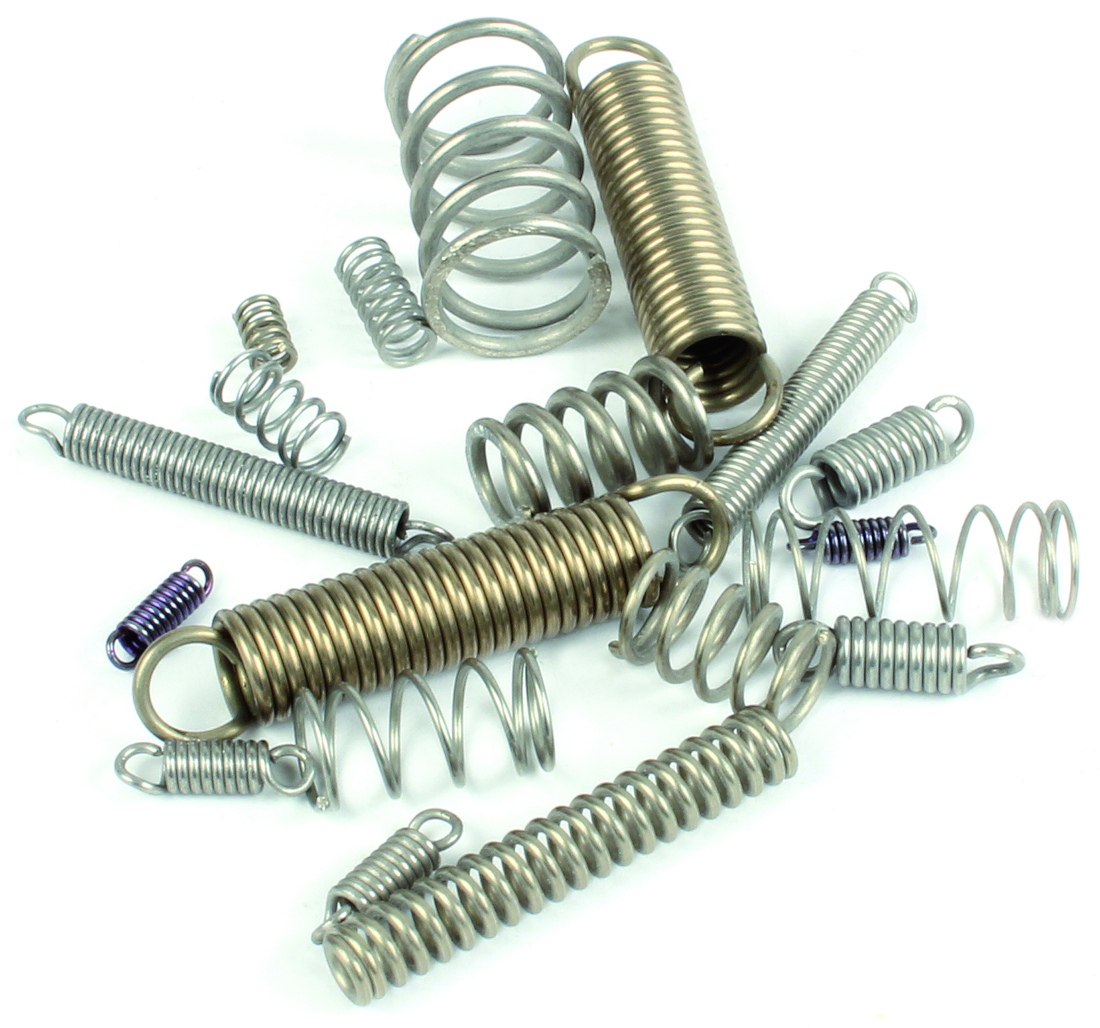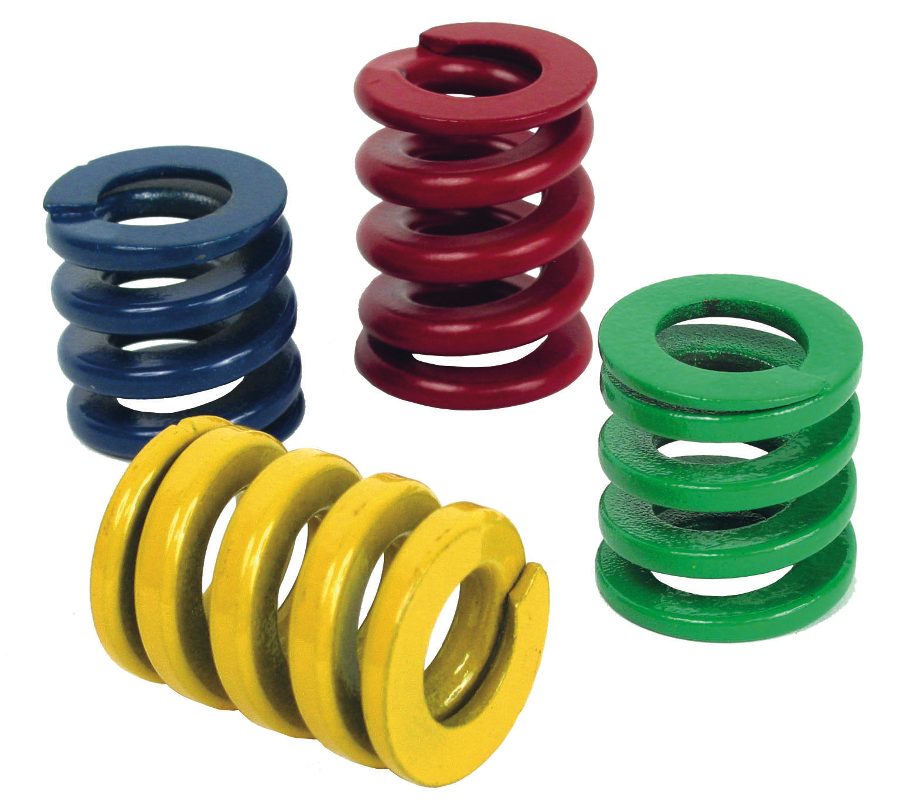

Increased stock of a large number of models.

ENGRENAGES HPC now offers a complete range of springs: compression springs to DIN 2095 (stainless steel strings CrNi17.7), tension spring to DIN 2097 (stainless steel strings CrNi17.7), stainless steel torsion spring 302 AMS 5688, ISO 10243 die springs, and 1 metre long tension
and compression springs that can be cut to the required length.

Compression springs (right handed winding) and traction springs are recommended for medium static and dynamic loads. The metre-length springs (to be cut to the required length) are available in steel or stainless steel.

The torsion springs are left wound as standard but right wound versions are also available.

Die springs are mechanical components that are designed to withstand shocks and bumps without suffering any permanent deformation. They are manufactured from trapezoidal wire which allows them to reach maximum deflection while guaranteeing protection against risk of damage caused
by excessive overloads. The standard range is available in several load capacities: coloured green
for light loads, blue for medium loads, red for heavy loads and yellow for extra heavy loads.

The catalogue has a wide range of sizes and dimensions for each type of spring.

HPC offers a custom manufacture service traction, compression and torsion springs,
please contact us for more information.

