Machine feet -
Full range
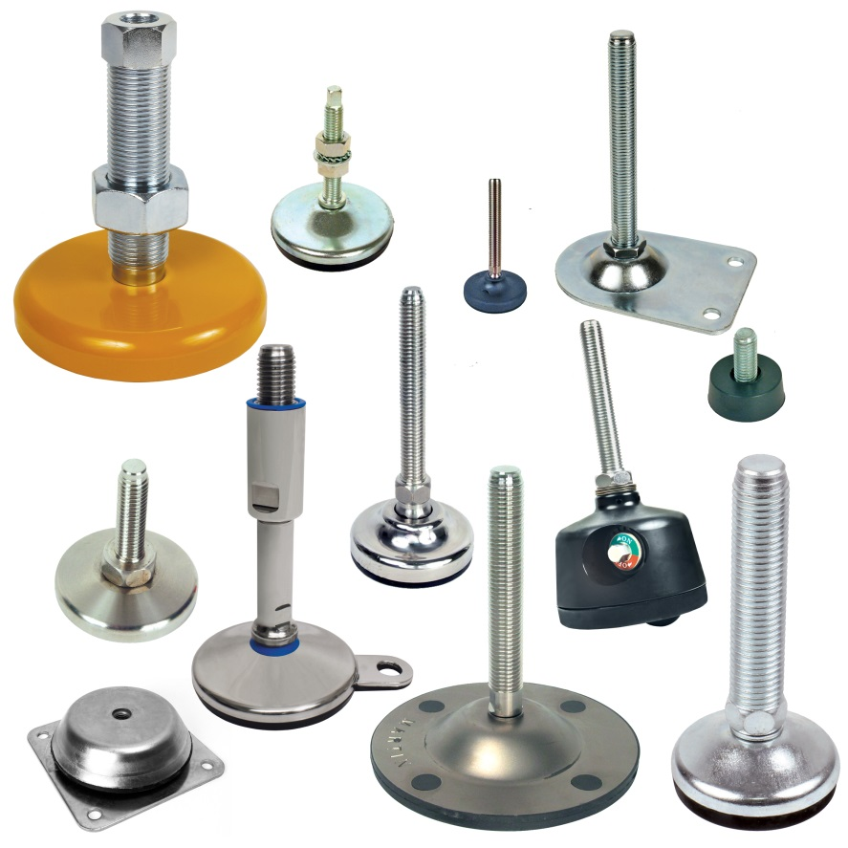

ENGRENAGES HPC offers a wide range of feet for all types of industrial applications. Amongst the extensive range can be found:
- Fixable ball feet with diameters from 40 to 123mm with non-slip rubber soles ensuring flexibility and grip. The spherical ended rod allows self-alignment with the floor.
- Articulated feet with sheet metal bases with diameters from 50 to 100mm, that allow inclination of up to +/-10° from the vertical. Two different finishes, sandblasted or brilliant are available.
- Solid stainless-steel ball and socket feet with diameters from 50 to 100mm and that also have non-slip soles.
- Solid levelling feet for heavy loads of up to 90,000N that offer precise adjustment thanks to special fine pitched threads. These models are ideal for use on assembly machines or automation lines.
- Rubber machine feet with 2 or 4 mounting holes that can be used as anti-vibration mounts for all types of machines and motors.
- Adjustable anti-vibration fixed feet that are perfect for injection machines, presses, compressors...
- Fixed feet with anchor points that can be used with heavy loads up to 40,000N.

Most models are available in both steel and stainless steel.

The range of mounting feet has been recently expanded to include two new types:
- Stainless steel oscillating articulated feet designed to meet Standard 3-A Sanitary Standards thus meeting the hygiene requirements of the dairy, food and pharmaceutical industries.
- Mounting feet with integrated castors that combine the advantages of a static foot and a castor and allows the quick and easy movement of a piece of equipment or a machine.

