Telescopic slides-
full range

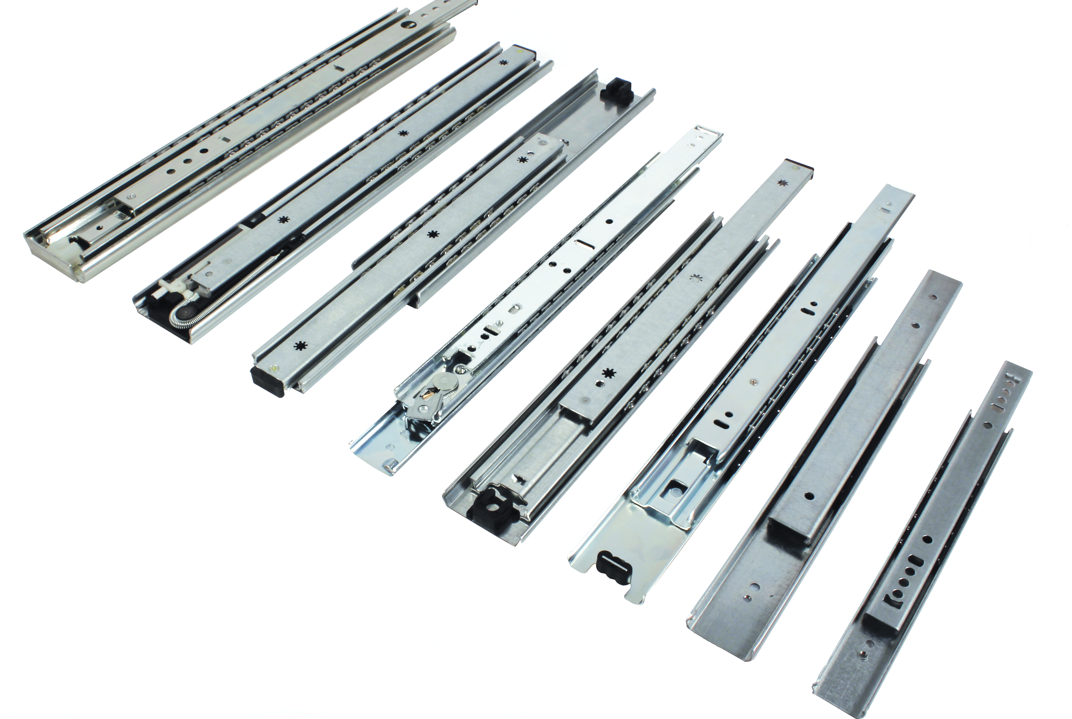

ENGRENAGES HPC now offers a complete range of telescopic slides that can be used in many industrial or commercial drawer applications (such as electronic cabinets, test benches, automatic dispensers for sweets, passes or tickets) They can also be used in many applications related to transport (such as emergency vehicles, trucks...).
The HPC range is available in several load capacities up to 200kg. As well as a miniature version, there are others that extend partially, fully or have an increased reach. These telescopic slides are designed to meet all the users requirements in terms of opening, comfort and accessibility. The 2-rail models are an economical low-friction solution for guiding drawers. The 3-rail models with integral extension have separable inner slides that allow the inner and outer profiles to be detached whereas the expanded extension models offer an extended reach for special applications.

