Round tubular structures for creating modular workstations
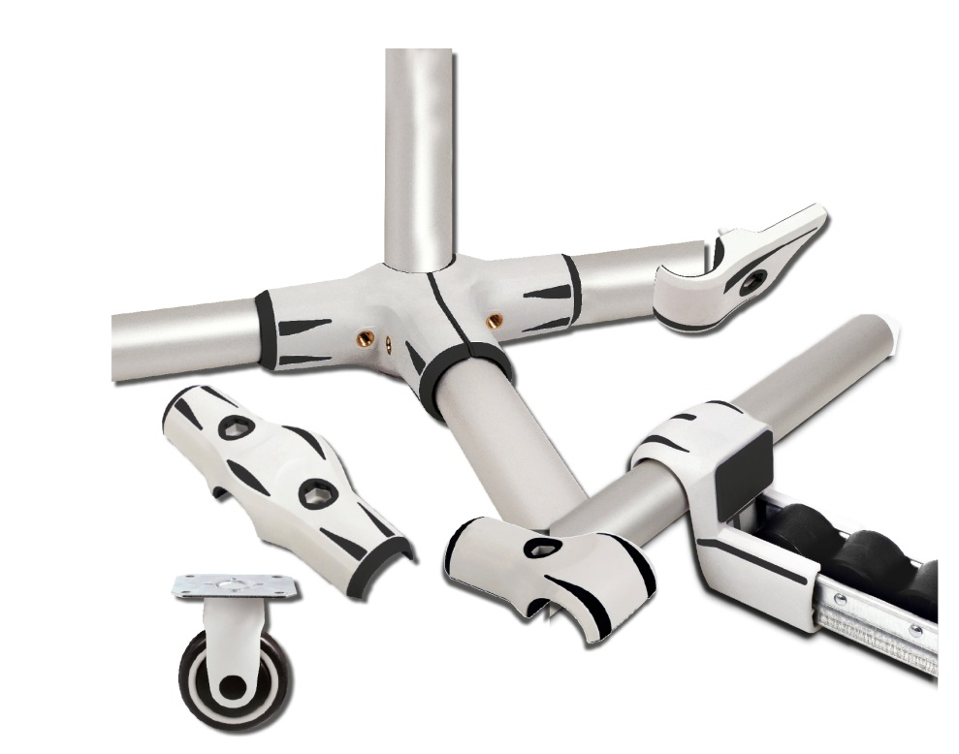

ENGRENAGES HPC has a complete range of components and accessories for creating modular structures from round tubes.

This innovative system which is based on the use of modular round tubes, allows the user to create or modify both fixed and mobile structures very easily. Companies find that this modularity and flexibility responds to their requirements to be able to rapidly create or adapt furniture and workstations to their ever-changing needs.

Each assembly is made up of aluminium, stainless steel or carbon tubes which are connected to each other by connectors made of very rigid and robust polymeric materials, which allow for easy and fast assembly. Available elements include multi-shape connectors (multi-axis, 45°, 90°...), roller tracks, castors and feet.

Compared to similar systems, this one based on a principle of tubes and connectors is the most flexible, easily accessible and scalable of all material handling systems. It meets all requirements in terms of shock resistance, hardness, design and durability. Pushing the concept of modularity to the extreme allows easy and fast disassembly/re-assembly for changing only a defective part, resulting in a lower cost. All of the separate elements can be completely dismantled and then reassembled to create another structure according to your current requirements.

There are many possible applications for this system such as improvements to existing workstations, furniture, shelves, display racks, sideboards, trolleys, etc and they are used in diverse industrial sectors such as Health, Distribution, Distance Selling, Logistics, the Food industry, Luxury and High-Tech industries etc.

