Index Bolts-
full range

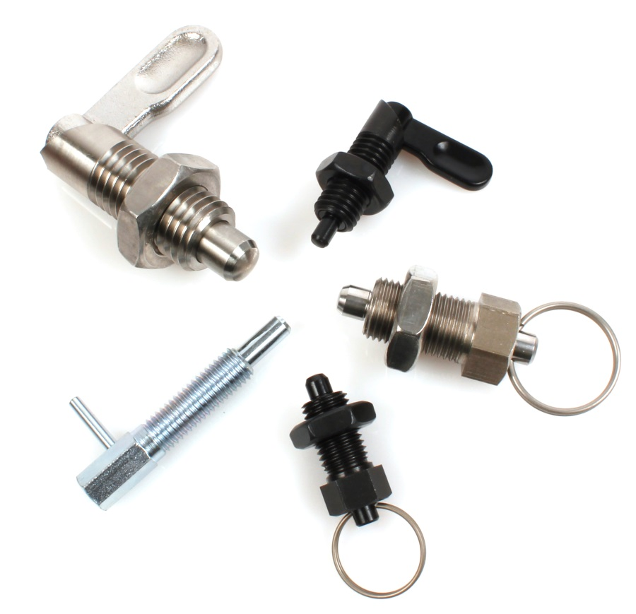

ENGRENAGES HPC now offers a complete range of indexing bolts. Used to block unwanted transverse movements, these index bolts are available in several versions; lockable, with a ring, lever or with horizontal fixing flange. The indexing fingers are operated by pulling a knob or by turning a lever. The ring versions are ideal for use in automated systems (for example, using a pneumatic cylinder or a remote control system).
Available in steel or stainless steel, they are perfect for all applications even in hostile or aggressive environments.

