Brushes, a new complete range from HPC

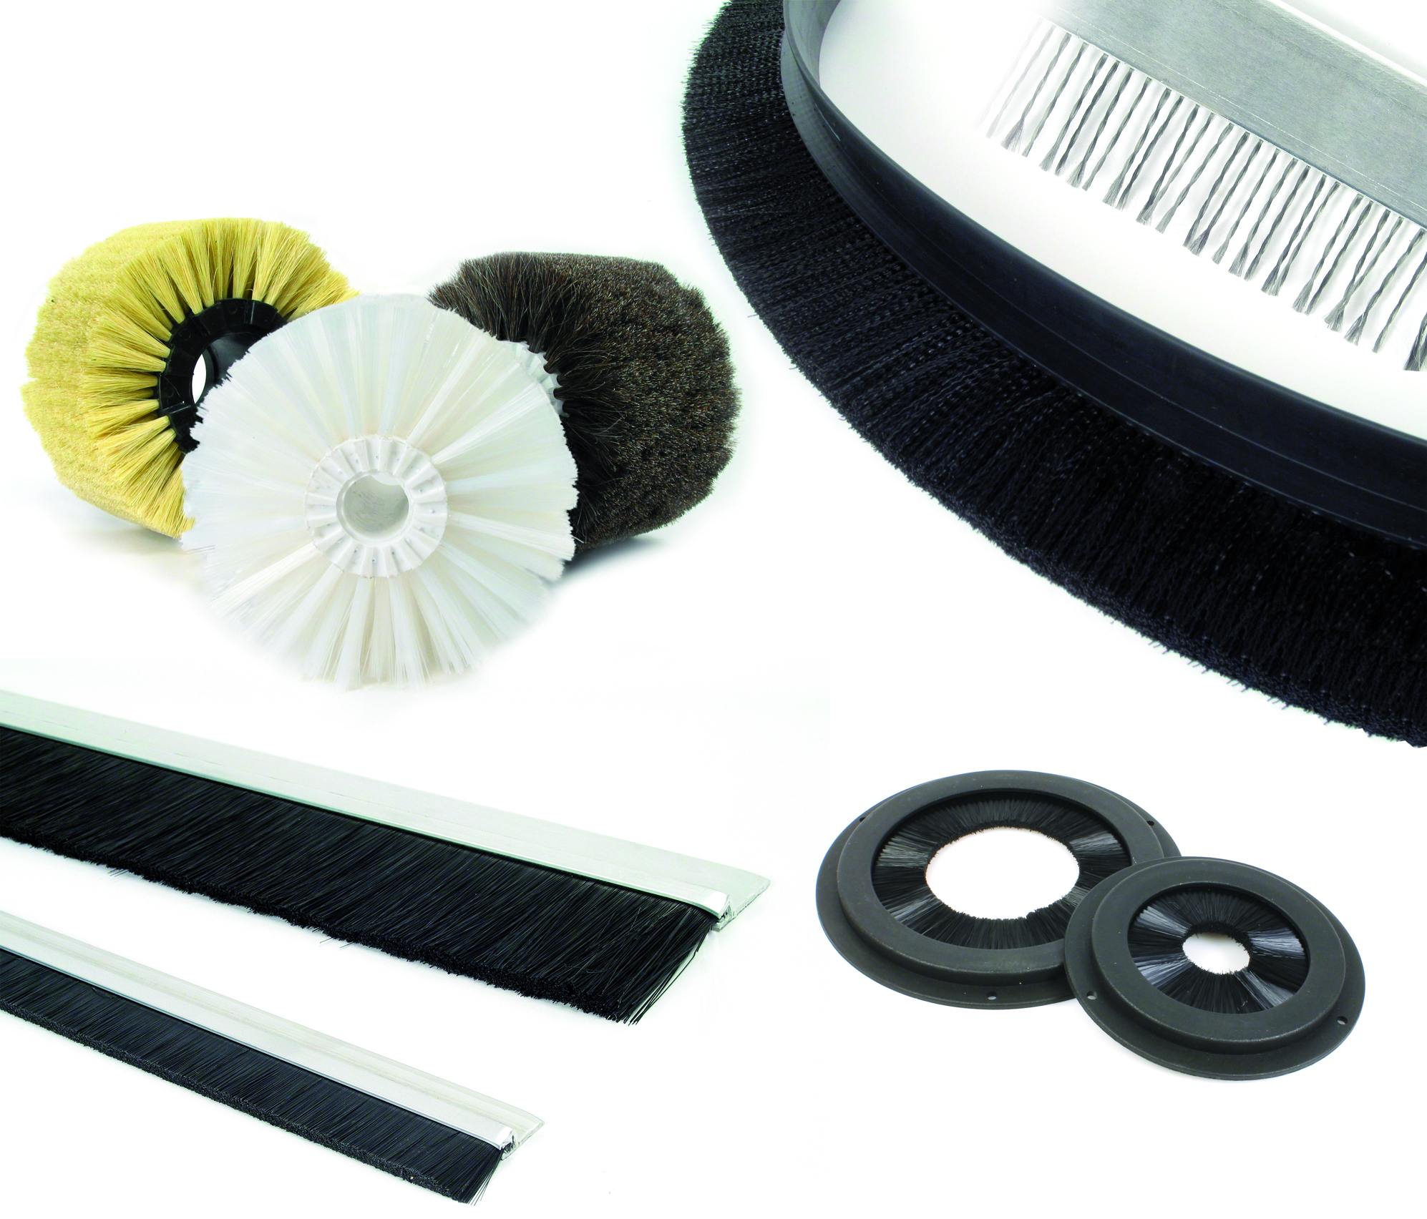

ENGRENAGES HPC's latest catalogue now includes a wider range of industrial brushes. They are available in different shapes and materials to meet the different needs of users in many industrial sectors. The versions available include modular cylindrical brushes, sealing brushes and antistatic brushes.
Modular cylindrical brushes are very simple to use and can be used in a large number of applications such as washing, conveying, dusting or transporting. The length of each brush is 100mm but the effective length can be increased by mounting multiple brushes on the same shaft. Teeth on the brush bodies lock together to facilitate fast and efficient positioning. A locking ring placed at each end will prevent lateral movement and ensure rotation. The wires are made of PBT Polyester, horsehair or Tampico and are available in several densities; low, medium or high.
Sealing brushes can be supplied either by the metre, mounted on a rigid support or in a circular shape. The basic type offer a great deal of flexibility and are easy to install as they can be moulded to virtually any shape and can be quickly cut to the length required. They are ideal for sealing cable entries on enclosures or guiding products that are moving. The versions mounted on supports are ideal for sealing the bottom of doors, gates or roller shutters. Recently added to the catalogue, the ring brushes can be used for sealing and cleaning shafts. They are intended to seal or protect shafts or openings and are supplied ready to install.
Antistatic brushes are designed for use in the manufacture of plastic films and fabrics. They provide safe and effective protection as they avoid the generation of high static voltages and provide designated discharge points. They come in two versions with either special braided steel wires or carbon threads.
HPC Gears can also supply custom made brushes, for more information, visit the website www.hpceurope.com.

