Bearings and freewheels

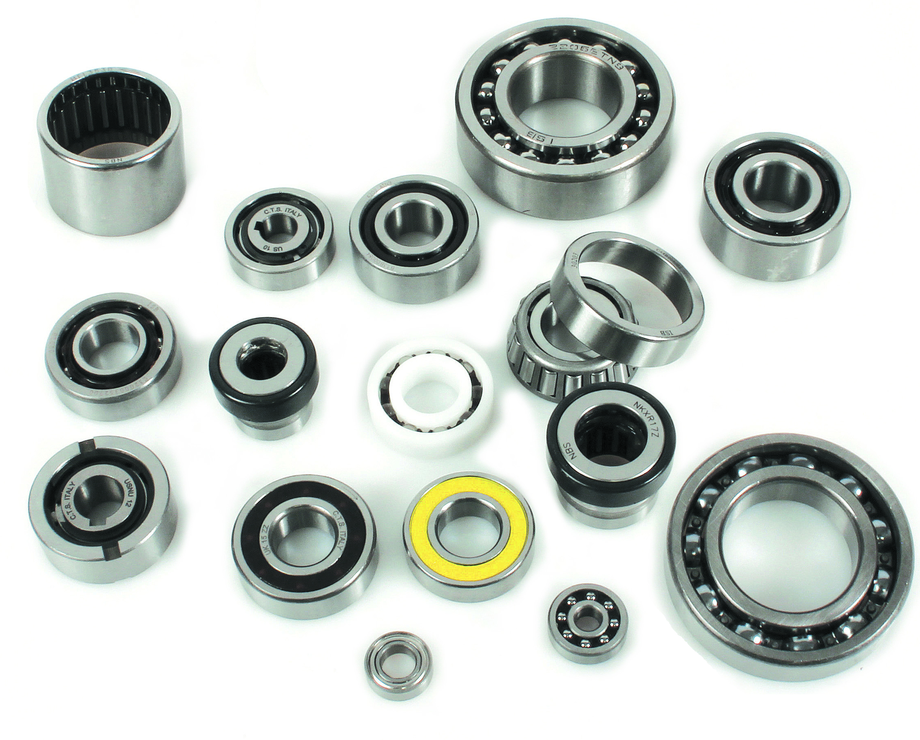

ENGRENAGES HPC is enlarging its range of rotary guidance products. The catalogue now contains radial contact ball bearings as well as angular contact ball bearings (with single or double rows of bearings), radial ball bearings, roller bearings (conical or cylindrical) and combined bearings ..

In addition, Engrenages HPC also offer a wide range of freewheels (Roller, ball or needle).

Available in various materials such as steel, stainless steel or even plastic, these bearings and freewheels can satisfy the needs of the most varied industries and meet the constraints of applications in hostile environments.

