Racks and gears,…

New low module ranges

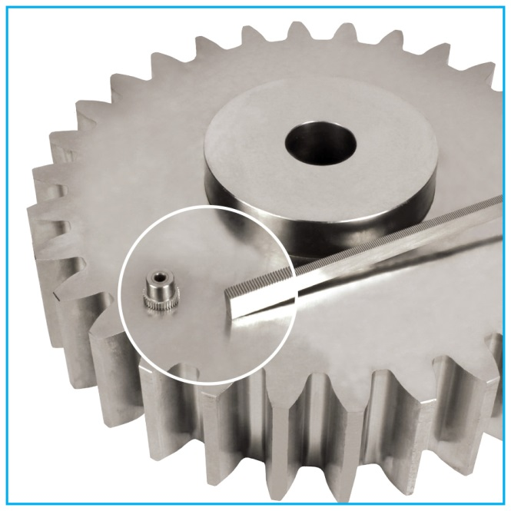

Specialised in the sale of gears for more than 20 years, ENGRENAGES HPC has added a wide range of low module (<1) gears, racks, wheels and worms in order to satisfy even more of the requirements of its customers. Many different models in steel, stainless steel or plastic are available from stock. All the different parts are sold individually and discounts are available subject to quantity. Most standard products can also be modified at the request of the customer or others manufactured to customers drawings.

The range includes:
- Stainless steel racks with modules from 0.25
- Steel and Delrin racks with modules from 0.4
- Stainless steel spur gears with modules from 0.25
- Steel, brass and Delrin spur gears with modules from 0.4
- Tapered steel, stainless steel and Delrin gears with modules from 0.8
- Steel and Delrin helical gears with modules from 0.5
- Wheels and worms with modules from 0.4
- Double stainless steel gears with modules from 0.4
- Double steel gears with modules from 0.5
- Stainless steel sprockets with modules from 0.25
- Internal gears in either steel and machined plastic with modules from 0.4

