Rotary tables
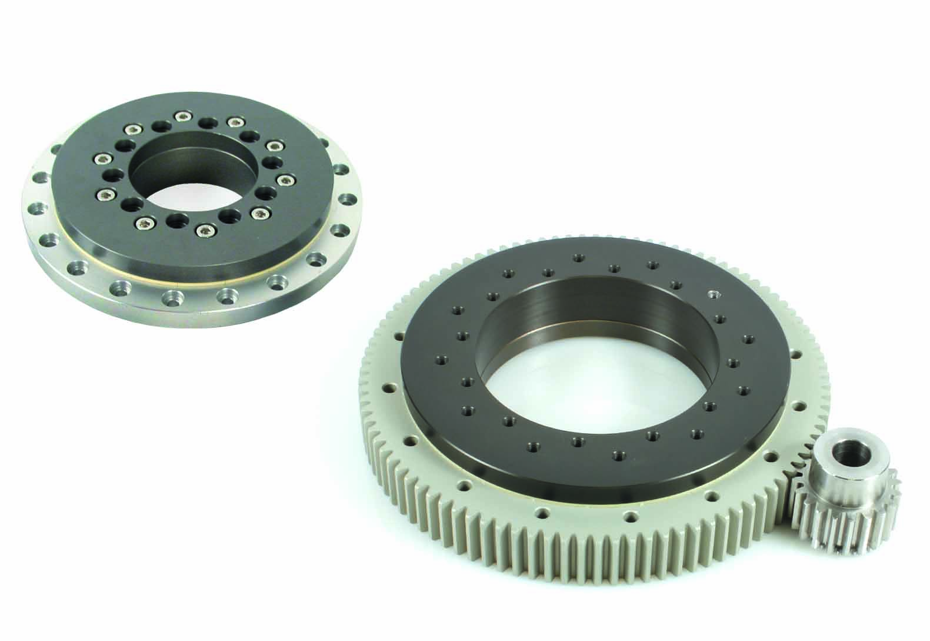
The Engrenages HPC catalogue includes an extensive range of rotary tables for use in conveying systems, automated machines or assembly lines. These tables are maintenance-free and have a very low coefficient of friction. Robust and easy to install, they also resist abrasion. A version with an external toothed ring can be used in combination with gears or T10, AT10 or HTD8M type pulleys.

