Locking Assemblies
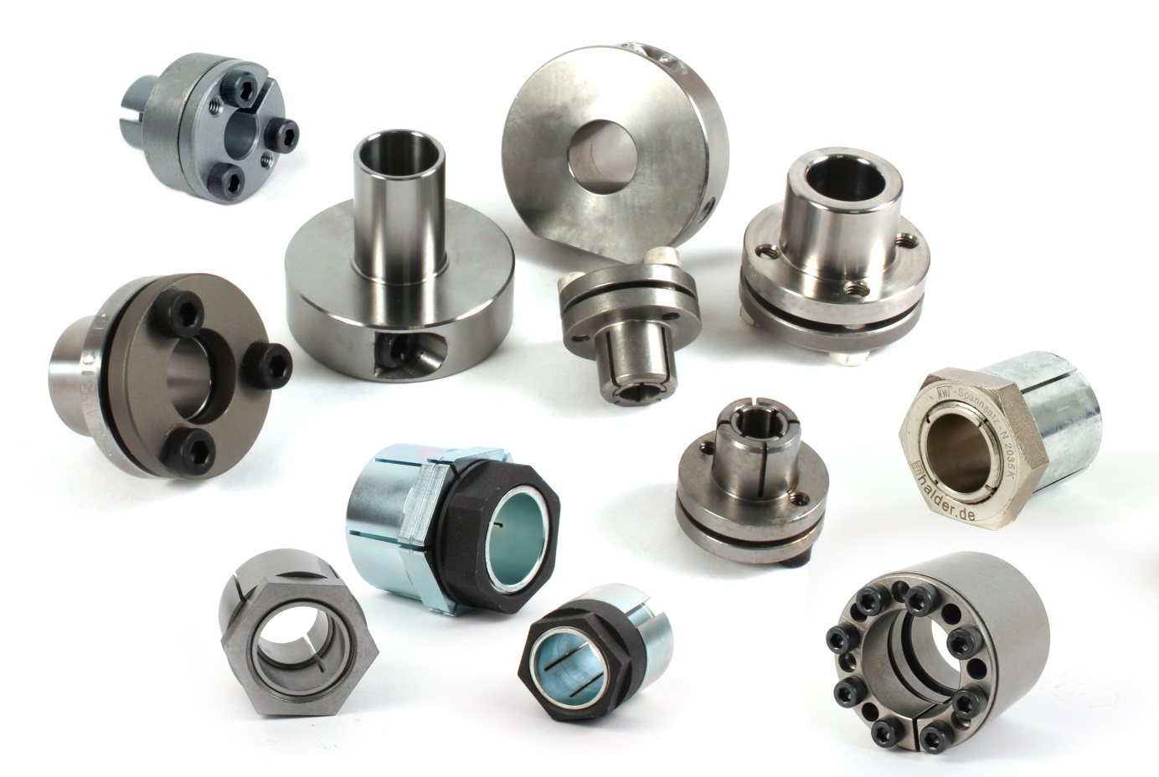
Engrenages HPC now has a wider range of locking assemblies in its catalogue. Used to lock an external part on to a shaft, the different models can either be self-centering or not, and use either mechanical or hydraulic locking. Suitable for low, medium or high torques, these frets benefit from good concentricity. The hydraulic models, which are available in steel or stainless steel can be assembled and disassembled easily with a single screw, which makes them perfect for applications requiring frequent mounting and dismantling.

