Alignment Shims now
available in kits or on reels

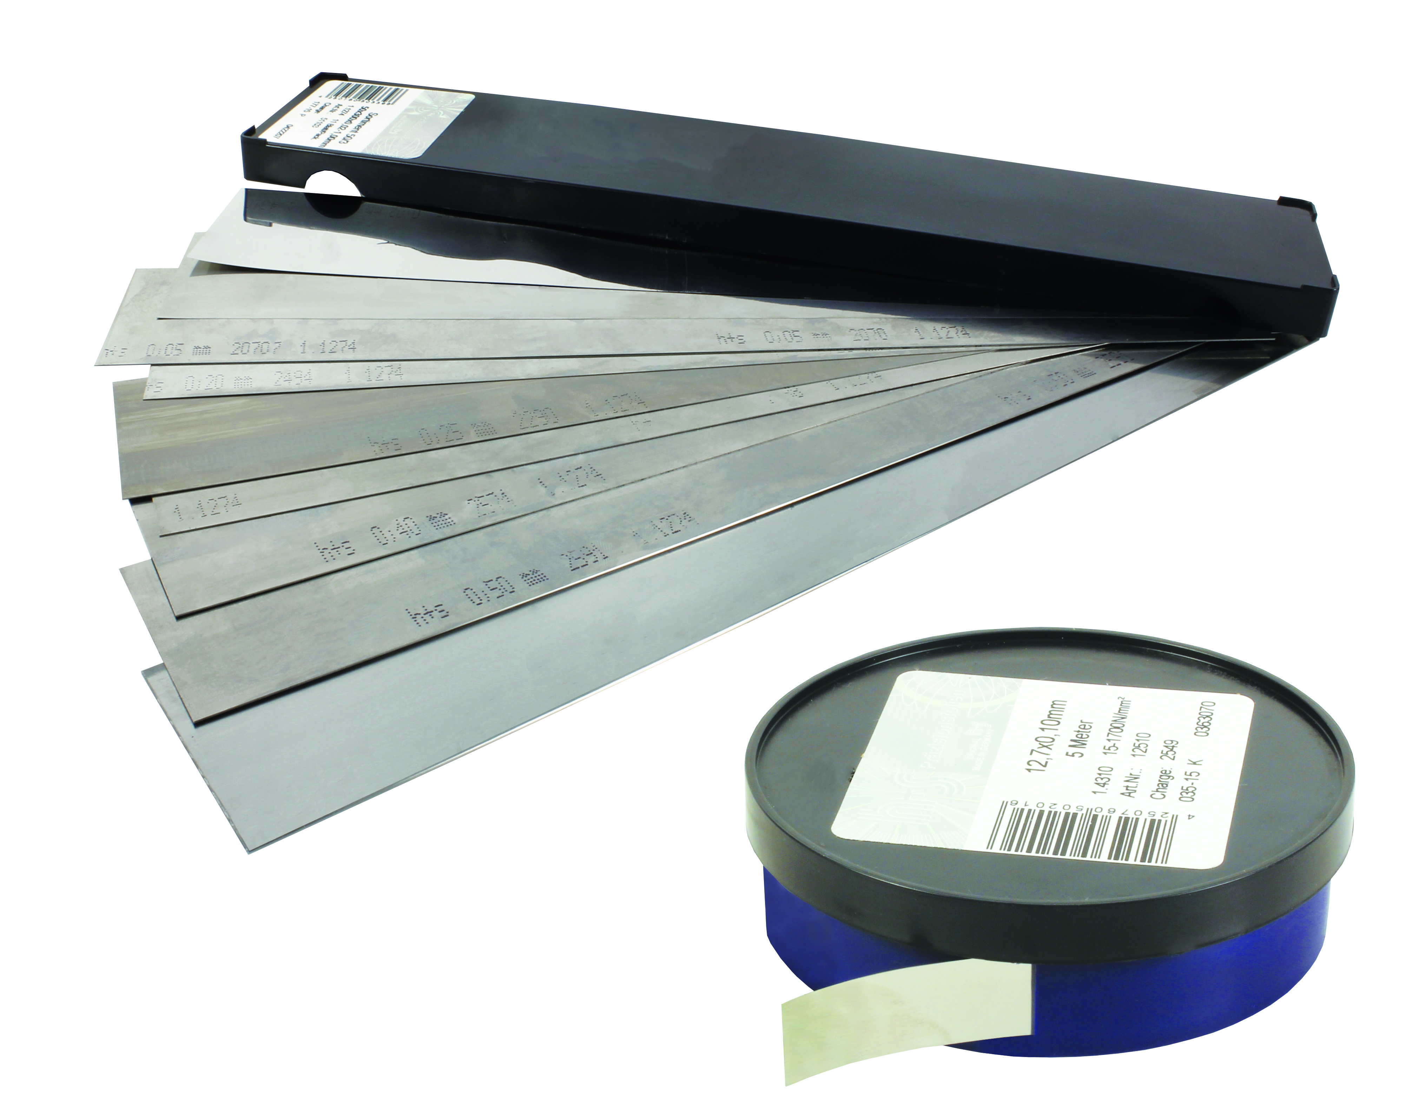
NEW FOR 2016!

ENGRENAGES HPC has added a new range of products to its catalogue that allow you to adjust, level, block or position your equipment.
With a wide choice of sizes in the kit, the precision shims, available in steel, stainless steel or brass can be cut to the size and form required. The large range of different thicknesses in each box allows accurate adjustments to be made in many different applications.
The reels of shims, available in steel and stainless steel allow shims to be cut to the length required.

Applications:
- Alignment of workpieces to be machined
- Aligning templates
- Valve clearance adjustment
- Tool setting
- Bearing adjustment
- Alignment of a motor and a pump before connecting the two

