Couplings-
Economy range

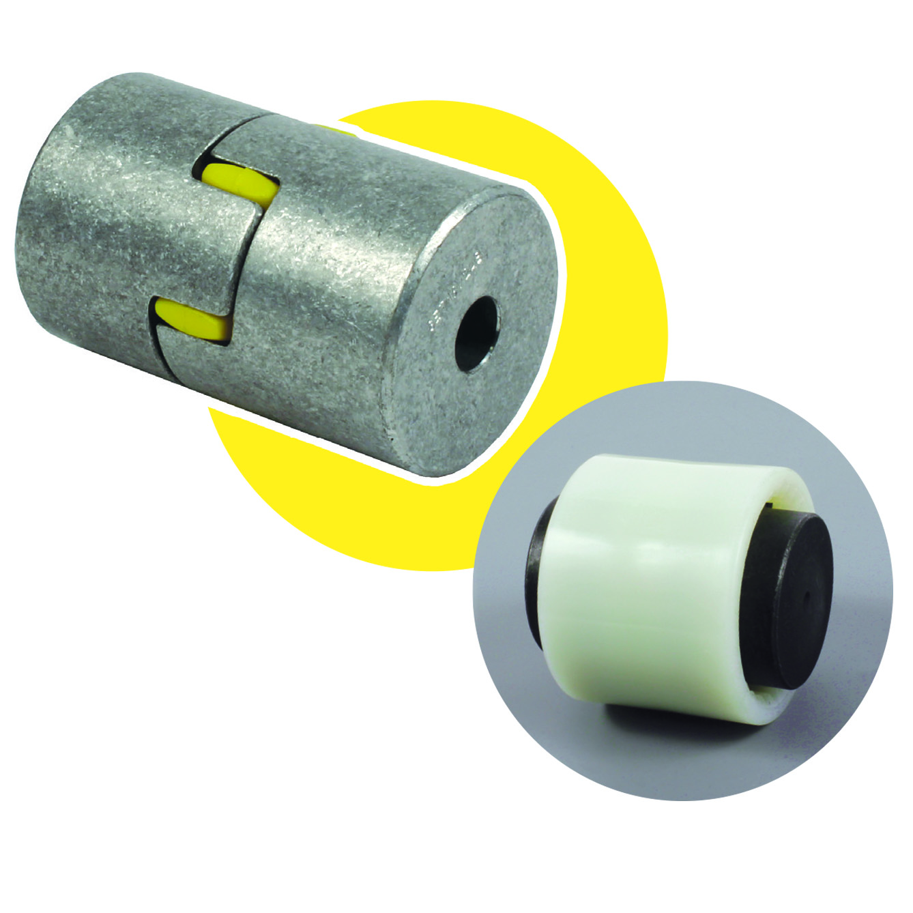

ENGRENAGES HPC completes its wide range of transmission couplings by adding two new models that offer great value for their price, these are a domed coupling and an elastic aluminium coupling. The 3 part assemblies are rigid in torsion and are specifically designed to transmit torque. They require no maintenance, absorb vibrations and are electrically insulated.

More detailed technical specifications are available in our catalogue and on our website.

