Manual gear reducers

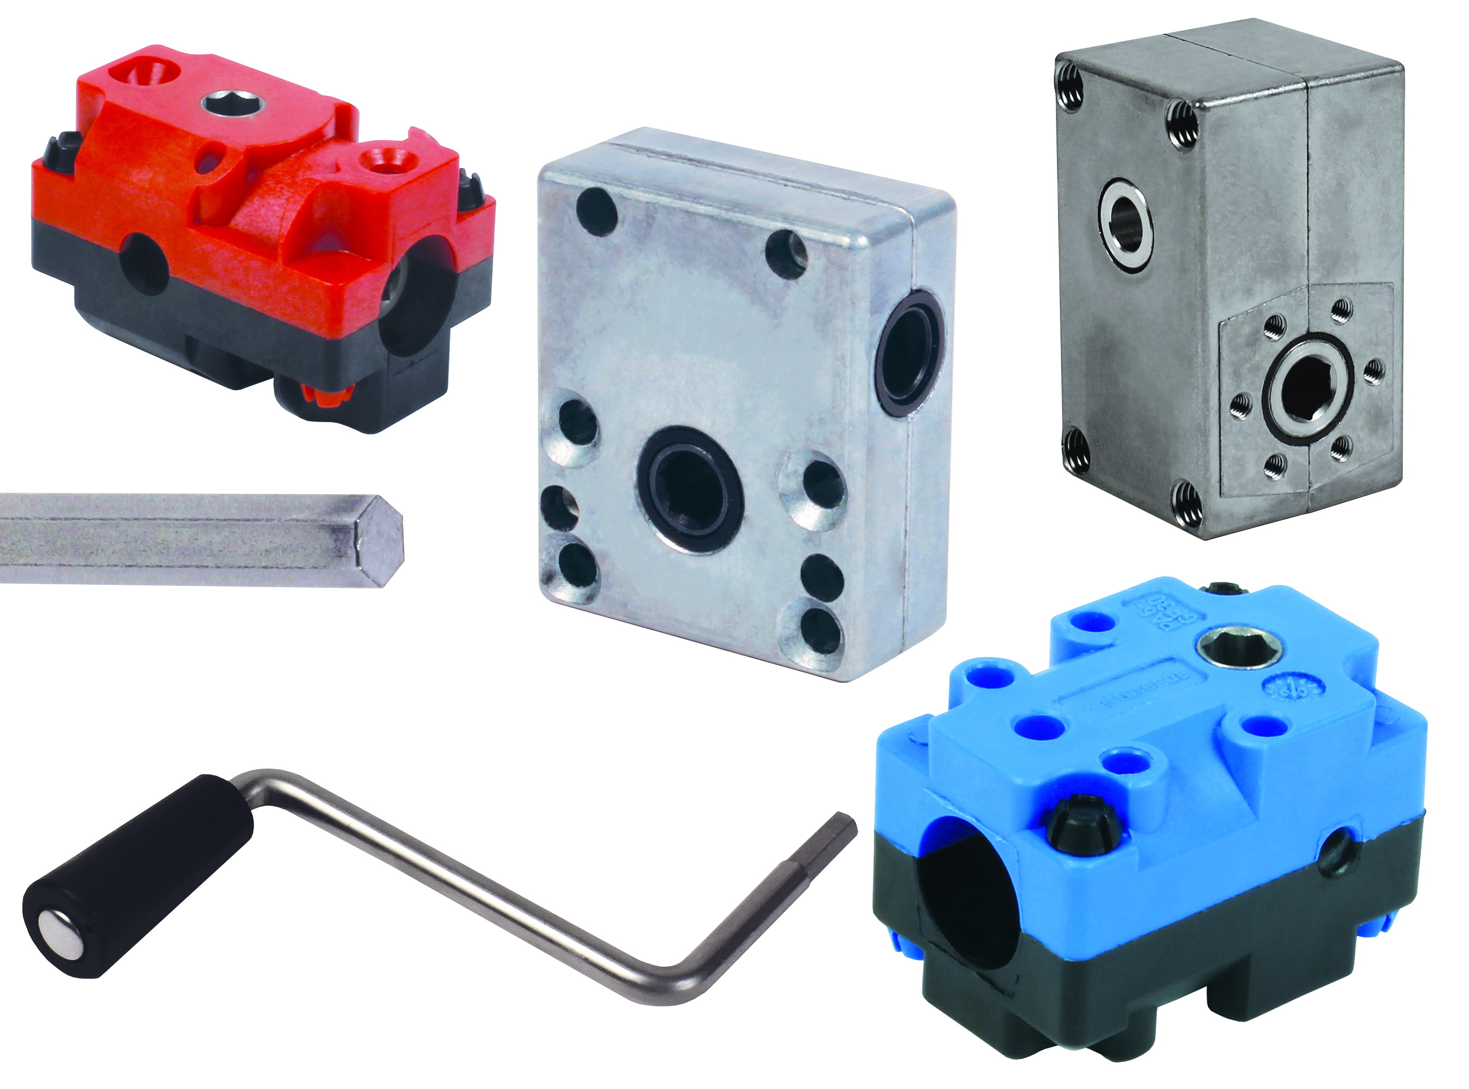

In 2015, ENGRENAGES HPC has completed its range of gear reducers by adding several manually operated versions.

This part of the range now comprises:
- Manually operated right angled gear reducers with ratios from 1:1 to 30:1
- Manually operated worm and wheel gear reducers with ratios from 1:1 to 23:1

General Characteristics:
- Housing in glass fibre reinforced Polyamide PA6 or Zamak (depending on model)
- Maximum torque up to 17Nm (depending on model)

Accessories:
- Hexagonal steel drive shaft
- Stainless steel operating handle with hexagonal end and plastic handle

Application :
- For any application requiring manual operation

