Measuring Equipment

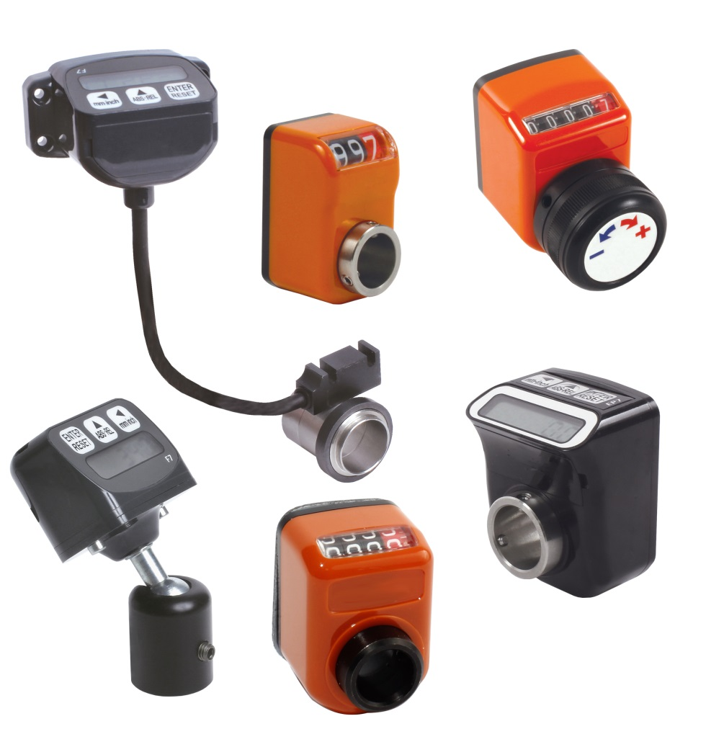
NEW FOR 2016!

ENGRENAGES HPC has a full range of measuring devices available. In the latest catalogue you will find a selection of 3, 4 and 5 digit position indicators including both mechanical and electronic versions. These devices are used to measure and display either linear or angular displacement. The latest addition to the range is a new multi-function device.

Digital position indicators:
Technical Characteristics (depends on model) :
- Display with 3, 4 or 5 digits (red digit to display tenths or hundreths), displays up to 9999
- Position Indicator with a hollow shaft
- Indicator with 3, 4 or 5 digits for the control or direct measure of a displacement (or rotation) obtained via the rotation of a drive shaft.
- Polycarbonate or Technopolymer inflammable shockproof housing. Ingress Protection IP64 or IP54.
- Height of digits: 5, 6 or 7mm
- Drive shaft hole diameter: 8, 10, 12, 14, 20 or 30mm (subject to model)
- Dustproof gasket

Accessories available (for 4 and 5 digit versions only) :

- Shaft reducer

- Locking collar

- Control knob

Digital position indicators:

General Characteristics:
- Power supply: external battery (1/2AA 3.6V)
- Battery life: 4 years (continuous use)
- Max speed:
  - 400 rpm (continuous use)
  - 1,000 rpm (for short periods )
- Display range: -999999 to +999999
- Display: LCD height 7.5mm
- Keypad: 3 keys for programming function selection
- Hardwearing shockproof inflammable housing
- Operating temperature: 0 to +50°C
- Relative Humidity: 35% to 85%
- Protection IP54
- EMC Compliance 2004/108/CE
Major features:
- Compact
- Easy to install
- Simple to program
Applications :
- Packing machines, wood treatment, aluminium, sheet metal…

Multifunction display (NEW) :

General Characteristics:
- Internal or external sensor
- Resolution : 0.1mm
- Max speed: 2,5m/s
- Display range: -99999 to +99999
- Display: LCD height 7.5mm
- Max distance between sensor and band: 1mm
- Keypad: 3 keys for programming function selection
- Sensor Ingress Protection: IP67
- Display Ingress Protection: IP54
- Operating temperature: 0 to +50°C
- Relative Humidity: 35% to 85%
- EMC Compliance 2004/108/CE
- Power supply: 1/2AA 3.6V (Lithium-thionyl chloride) battery
- Battery life: 4 years (continuous use)
Max speed:
  - 400 rpm (continuous use)
  - 1,000 rpm (for short periods )
- Hardwearing shockproof inflammable housing

Accessories available:
- Ring and magnetic band
- Surface or right angled mounting brackets
- Adjustable support brackets
Major features:
- Compact
- Easy to install
- Simple to program
Applications :
- Wood Machines, printing..…

