Accessories for Transport and Handling Systems

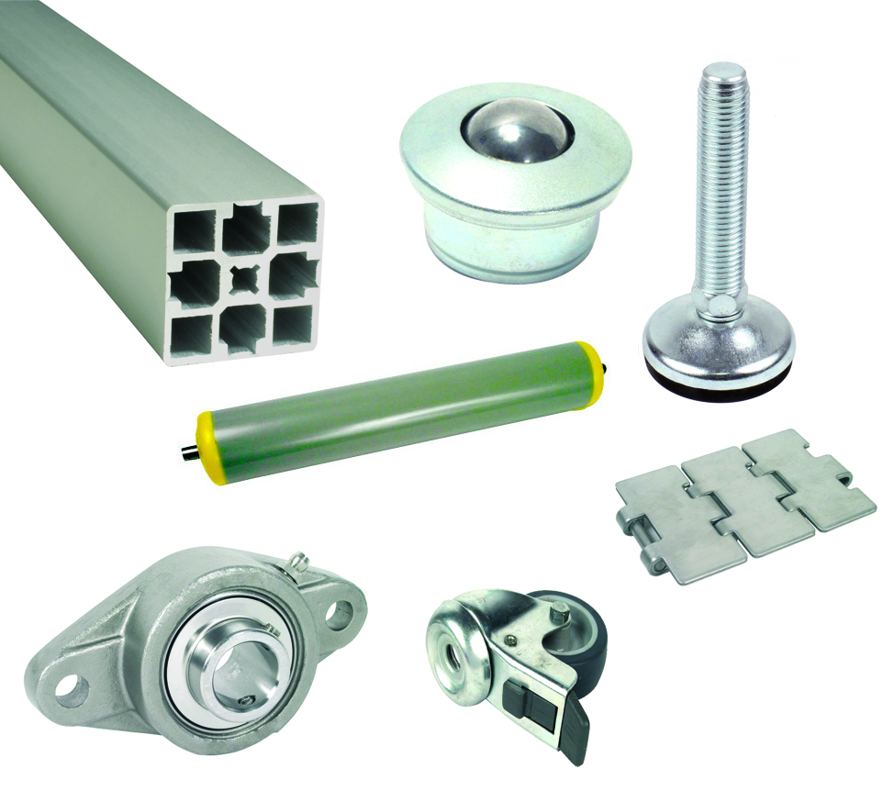
ENGRENAGES HPC's latest catalogue includes a wide range of accessories for your transport and handling systems. Amongst them you will find:
- Aluminium profiles and accessories (Mounting elements, cable supports…)
- Ball transfer units for a wide range of loads in steel, stainless steel or plastic
- Free rollers and omni-directional handling rollers for gravity fed handling systems
- Plate chains in either steel or stainless steel with a full range of accessories
- Flange units with roller bearings
- Casters and mounting feet for all types of loads in steel or stainless steel

Materials:
- A wide range of different materials are available

Applications:
- These accessories are suitable for use in a wide range of industries including the medical and food industries

